Lab Experiment: Basic Image Handling and Processing Operations
Experiment No: 5
Aim
To read an image using Python and perform image erosion using the erode() function in the OpenCV library.
Tools Required
- Python 3.x
- OpenCV (cv2)
- NumPy
- VS Code / PyCharm / Jupyter Notebook
- Input Image
Procedure
- Install the OpenCV library using:
- Import the required libraries (cv2 and numpy).
- Read the input image using cv2.imread().
- Create a kernel using numpy.ones().
- Apply the cv2.erode() function to erode the image.
- Display the original image and the eroded image.
- Wait for a key press and close all image windows.

Code
import cv2
import numpy as np

# Read image
img = cv2.imread("sample.jpeg")
gray = cv2.cvtColor(img, cv2.COLOR_BGR2GRAY)

# Create kernel
kernel = np.ones((5,5), np.uint8)

# Apply erosion
eroded = cv2.erode(gray, kernel, iterations=1)

# Display
cv2.imshow("Original", gray)
cv2.imshow("Eroded Image", eroded)

cv2.waitKey(0)
cv2.destroyAllWindows()
Output
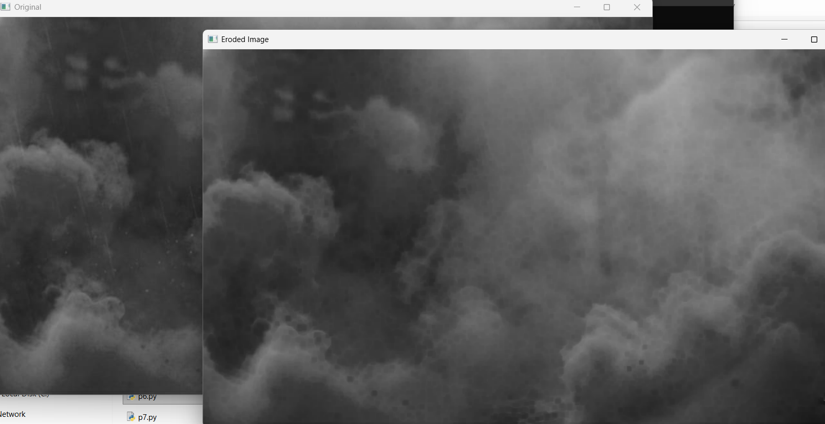
Result
The input image was successfully read using Python, and the cv2.erode() function was used to perform image erosion. The eroded image was displayed successfully.

